Sprint Two

South Metropolitan TAFE | [Company address]

Calvin moylan

30018702

2020

# Contents

Project Plan 3

Development Plan 3

Notes: 5

Meeting 5

Software Review Plan 6

Performance Report 7

Backend Code 7

Test Documentation 8

Master Documentation 8

Presentation 9

Meetings 9

Source Control System 0

Example 0

Sprint Two Finished GitHub 0

Main 0

Responsive Multiplatform site 1

Master Document and Reports 1

Requirements 2

Roles and Responsibilities 2

Performance report 3

Software Review Plan 6

Software Review 6

Performance 6

UI Design 7

Security 9

Client Requirements 10

Defect Tracking 11

Risks 11

Conclusion 12

Introduction 13

Scope 13

Features (Movie Database website) In Scope 13

Functional 13

Non- functional requirements 13

Quality Objective 13

Roles and Responsibilities 13

Test Methodology 14

RAD (Rapid application Development) 14

Testing strategy 14

Quality Assurance 14

Testing Environment 14

Hardware requirements 14

Test Cases 15

# Project Plan

Sprint Two of the Rapid App Development started on the 12th of November 2020 and will continue through the week until the 19th of November where the scrum master, Calvin, will present the completed tasks to the client which had been set by ACME Entertainment Ltd. Each member of the team was assigned to task which they had to complete before the deadline.

# Development Plan

For this week, we are to continue on what we have developed thus far, continuing from making the website support multiple platforms, setting up our working repository and completing report documents. We have separated last week’s code and reports from this weeks by making a new folder within the GitHub repository. The client has requested we have a membership signup page which will allow users of the site to sign up and receive newsletter emails from the website. They also requested that we have an Admin page which will be used to send newsletters and delete members from the database. For this plan to be successful, the website must meet the client’s requirements and expectations.

To ensure that we meet the expectations of the client, we followed QA cite ISO 9001 and 90003 to verify and validate the website’s functionality through a dynamic validating method and through the use of the black-box method as this client does not have the knowledge to understand what the code is doing behind the scenes. This is the best way to show that the code is working to someone who does not program themselves since if it all functions correctly, the code must be working.

|  |  |  |  |
| --- | --- | --- | --- |
| Task | Who Completed it | Who checked it | Was it good |
| Software Review Plan | Calvin Moylan | Panashe Madakasi | The Software Review Plan meets the requirements and is all good for submission to the client. All relevant information has been included. |
| Performance Report | Panashe Madakasi | Carl Haricombe | The performance report has been correctly conducted and included the information relating the website’s performance. |
| New Feature set Code | Panashe Madakasi | Carl Haricombe | The code for the features has been completed and meets the client’s requirements for this week’s sprint. |
| Test Document | Carl Haricombe | Panashe Madakasi | The test document has been completed which shows the new feature set all working correctly and as intended. Adding users to database works, sending emails works and deleting users from database works. |
| Master Document | Calvin Moylan | Carl Haricombe | The master document has been updated with all the information relating to this week’s sprint. There has been 3 new documents added to the master document this sprint. |
| Source Control System | Calvin Moylan and Carl Haricombe | Calvin Moylan and Carl Haricombe | The source control system has been updated to reflect this week’s progress and completion. |

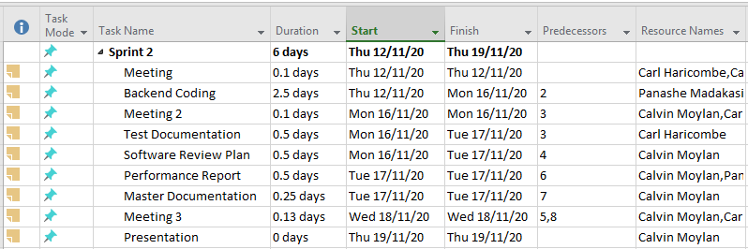

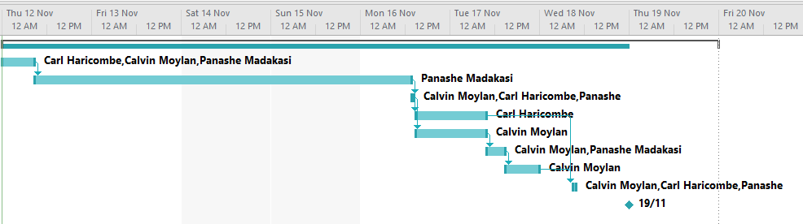

## Notes:

### Meeting

#### Meeting 1

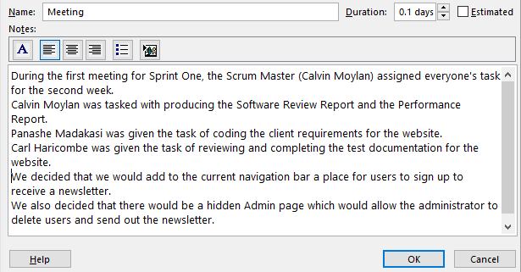

#### Meeting 2

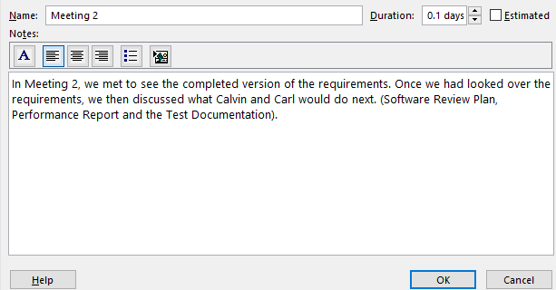

#### Meeting 3

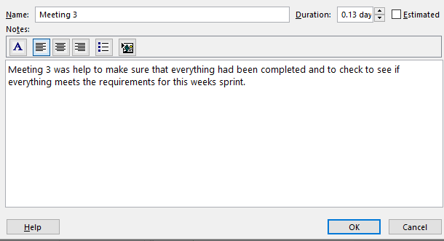

### Software Review Plan

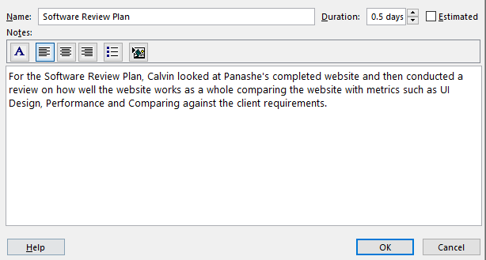

### Performance Report

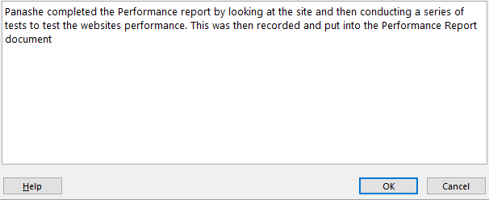

### Backend Code

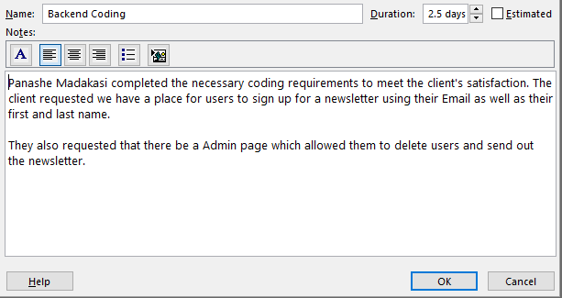

### Test Documentation

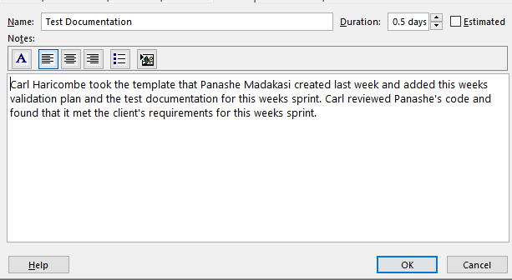

### Master Documentation

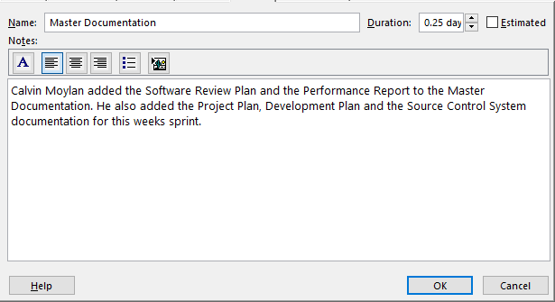

### Presentation

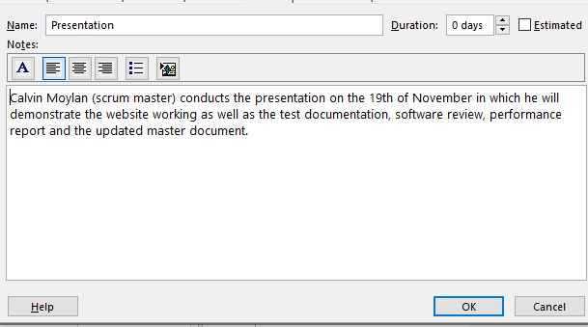

### Meetings

#### Meeting 2 (Monday 18/11/2020)

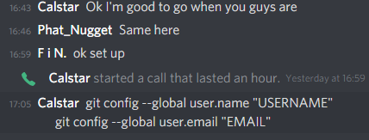

# Source Control System

In sprint two we are continuing using our existing GitHub repository from last week’s sprint. To separate each weeks work we have created different folders for each week example is shown below. We are continuing to use this repository as it already has our existing website and documentation on it. The source control system helps us to make sure we are always editing the latest version of the repository and makes sure that we always have a backup of our old changes.  
  
The repository this week was managed by Calvin with Carl uploading his documents to the repo and Panache uploading the completed version of the website.

## Example

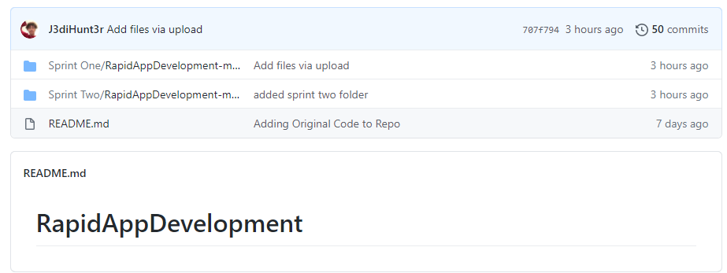

This shows that that we have split off from Sprint One and have moved onto working in Sprint Two where we will complete the client’s requirements for this week’s sprint.

## Sprint Two Finished GitHub

### Main

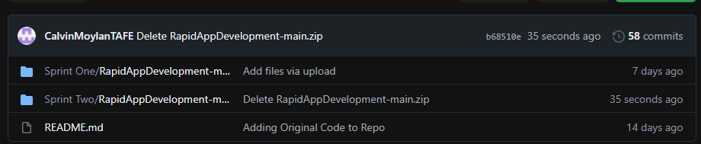

### Responsive Multiplatform site

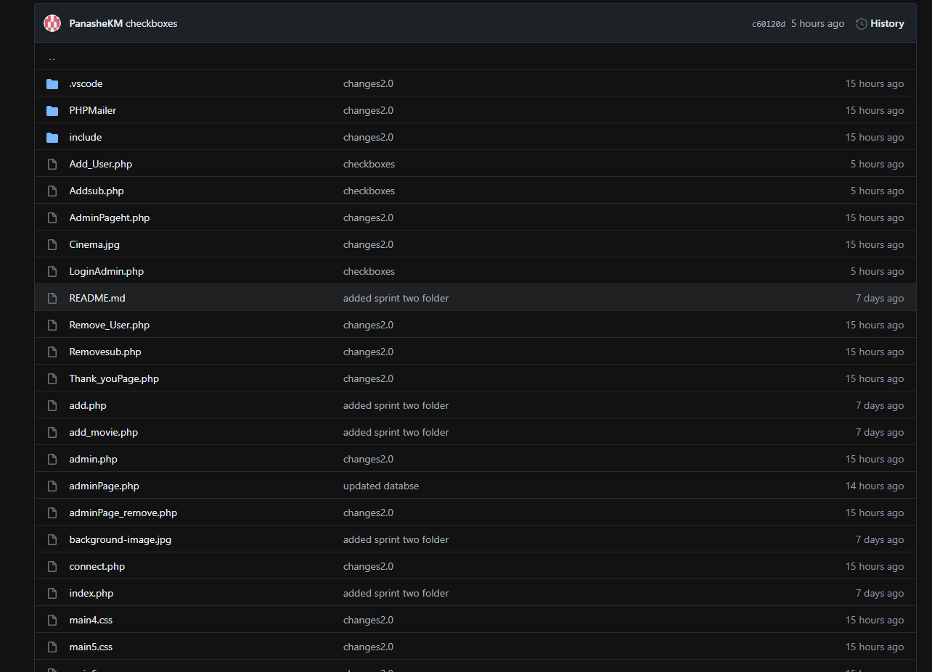

### Master Document and Reports

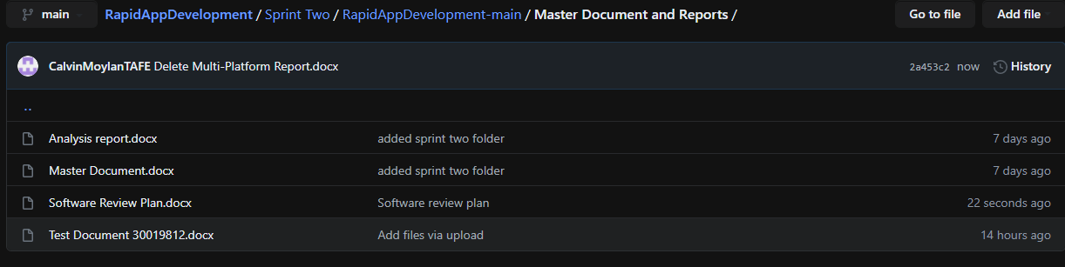

# Requirements

AMCE Entertainment has asked us to add new features to the website for sprint two of the Rapid App Development. The requirements are to include a membership sign up page which will allow for users to enter their full name and email to receive newsletters from the website. They will have the option of subscribing to this newsletter. They also asked us to provide an Admin page where they will be able to view all members of the database, delete members from the database as well as send out the newsletter.

# Roles and Responsibilities

Calvin Moylan (Scrum Master)

* Project management plan (sprint two)
* Software Review Plan
* Performance Report
* Demonstration
* Source control
* Updated the Source Control (Github)

Panashe Madakasi

* Coding (Developer)
* Performance Report
* Updated the Source Control (Github)

Carl Haricombe

* Software Development Testing Plan

# Performance report

Environment Used to develop

* Visual Studio Code

-Visual studio Code is a code editor

PHP and HTML

-Php and HTML are both coding languages used to develop this website

* Xampp control panel

Apache

MySQL (SQL Database)

Movie Database

* Web Browser

Chrome

Internet explorer

Microsoft edge

* Text editor

Word

Notepad

Notepad++

Code optimizations

* Code optimization is a process of changing or modifying software to it more efficient, improving the system’s efficiency by making the system to use less resources (Processor or memory) which results in a faster machine and freeing up the resources to be used by another process.
* Optimization is also referred to as a transformation technique, using low-level programing to be more efficient, there are many ways to optimize programs including;

- The use of algorithms

-

- Machine-independent Optimization

In Machine optimization the compiler takes the code and edits parts of the code that do not involve any CPU register. (example)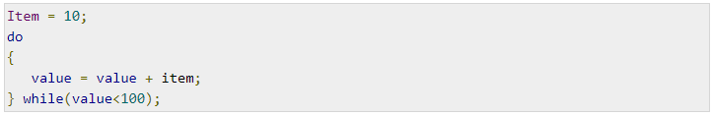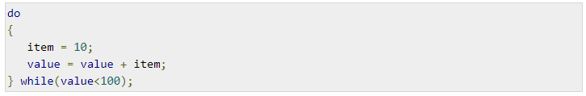

Machine-dependent Optimization

* Machine dependent optimization, is done once the code has been compiled and changed according to the target machine hardware, the use of the CPU register allows for absolute memory reference allowing for the optimizer to take full advantage of the memory hierarchy.

Performance tools

|  |  |
| --- | --- |
| Tools |  |
| - **Php_Code** sniffer is a set of scripts that read through php code and detects any errors or violation with against the pear code standard and fixes them accordingly, the use of code sniffers in development can be very useful for keeping code clean and consistent. |  |
| -**WebPageTets.org** is a website performance tool that tests speeds from multiple location around the world using consumer browsers, testing results provided detailed diagnostics like page speeds and recourse loading charts. |  |
| -is an application used for testing web or server based applications, once this tool has analyzed the website it identifies changes that can be made to increase efficiency. | **C:\Users\student\Documents\Capture.PNG** |

.

# Software Review Plan

A plan for reviewing this week’s software product must be conducted to ensure the requirements of the client has been met and to ensure that they will be satisfied with the end product. Below is outlined what the new website feature set will compared against. These must be in line with the CITE Managed Services QA.

I will make sure that the requirements of the product has been met by performing a review of the finished software by comparing it against the performance of the website, the UI design, security and the feature requirements set by the client.

## Software Review

### Performance

The performance of the website must be quick. Users will not want to spend their time waiting for a webpage to load. Luckily for us, this website does not use any hardware intensity code just as JavaScript so all the user’s web browser has to do is render the HTML sent by the server. The user sign up and admin portal all happen on the server side so the user does not have to worry about having to wait long periods of time for their browser to handle it. Having the server handle all sensitive requests is also makes the website secure.

The website was originally written by Calvin which was then improved upon by Panashe during the second week of sprints.

Here is a list of performance stats:  
Index Page: 0.0002 seconds  


Searching for all movies: 0.0432 seconds  
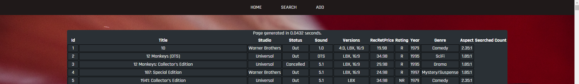

Admin Page: 0.0359 seconds  
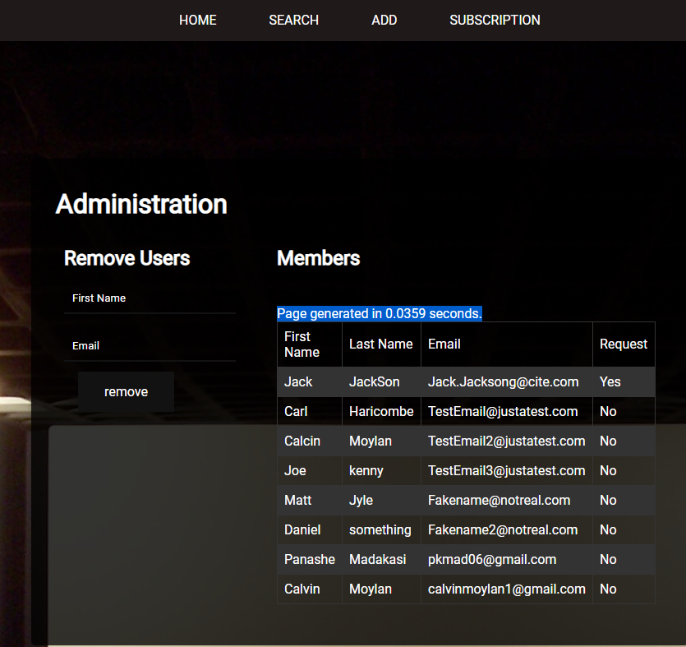

### UI Design

The UI Design must be simplistic and easy to navigate. We went about this by having one ribbon navigation bar across the top of the screen which has all pages that is accessible to the users of the website. The UI must also be cross platform compatible which was completed last week during sprint one but also must be applied to this week’s sprint.  
Index:  


Search:  
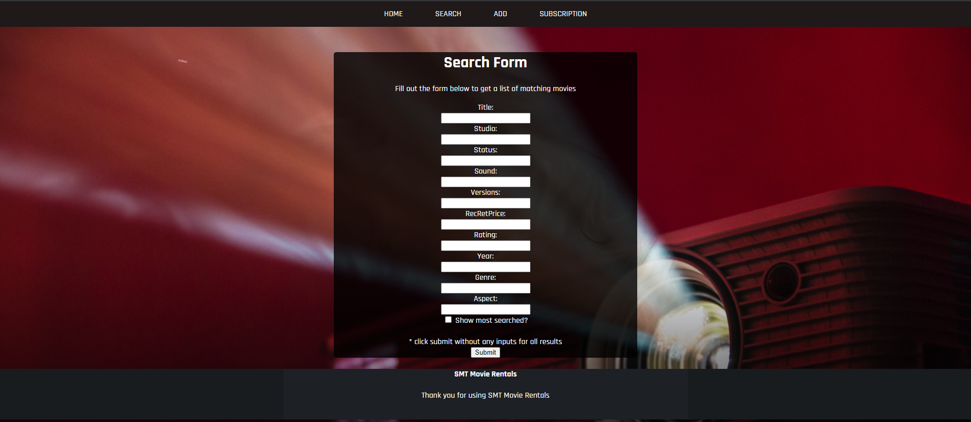

Add:  
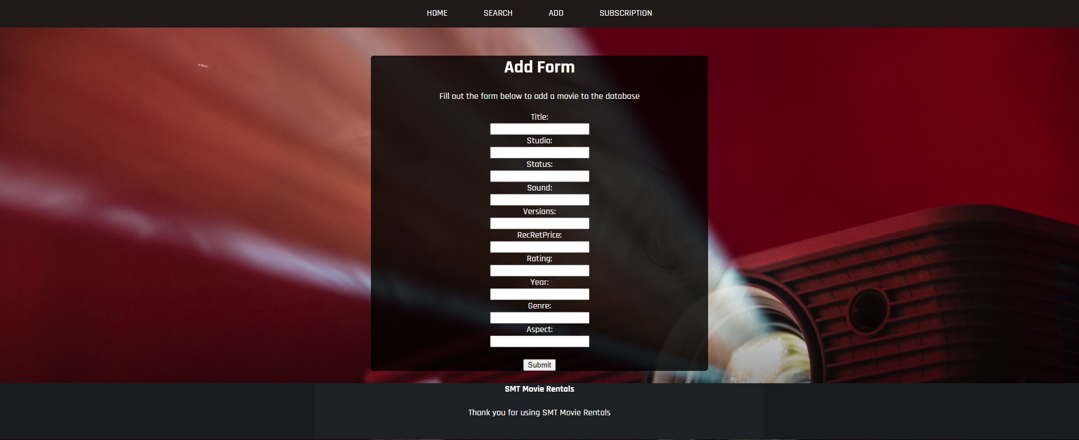

Subscription:  
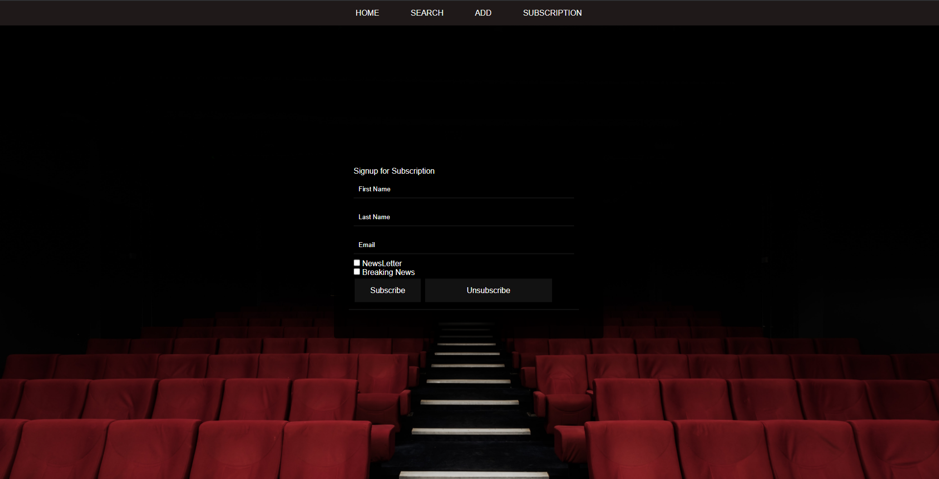

The UI Design is simple and is consistent across the entire website.

### Security

The website must be secure. If the website is not secure this could lead to devastating effects for the end user which may include having their personal email leaked to the public.  
To ensure that the website is secure, I used CITE’s quality control to identify problematic bits of code and to sniff out any problems with the website’s code. I figured the areas that would be prone to security faults would be the user inputs. E.g. name entering. These inputs must be filtered and sanitised before being entered into the database.  
Another security hole may be the SQL connection. We have chosen to use PDO, this is because it is more secure than MySQLi.

We have completed a test case document and code review to ensure that the website is as secure as possible.

We also used a PHPSniffer to detect any errors:  
<https://phpstan.org/>

Admin page:  
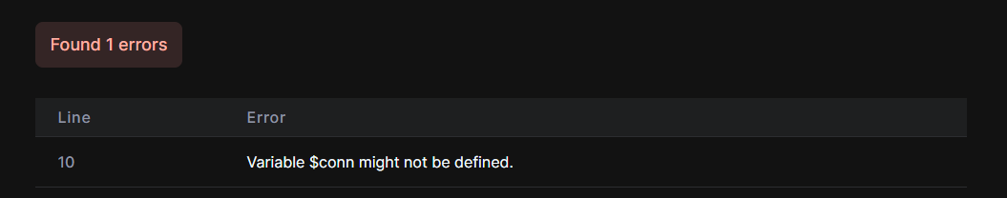

Adding Member:  
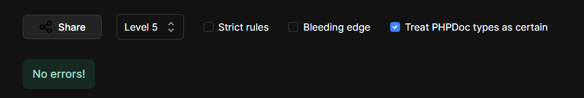

Admin Login:  
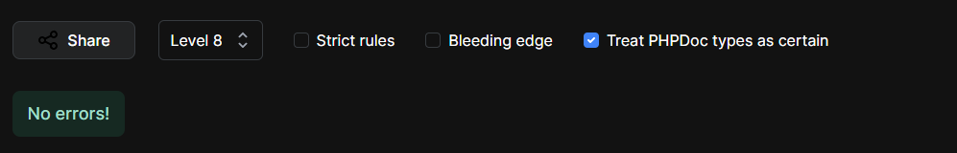

We reviewed these and made changes accordingly.

### Client Requirements

The website meets the client’s requirements.  
The requirements were that we must include a membership signup page with an option to sign up to newsletters. See below:   
We were also required to include an Admin page. See below:   
The admin page also required functionality to see all members and to delete them. See below:   
Finally, the website must also be able to send newsletters out to the members who have subscribed to them. See below:

Admin Page:  
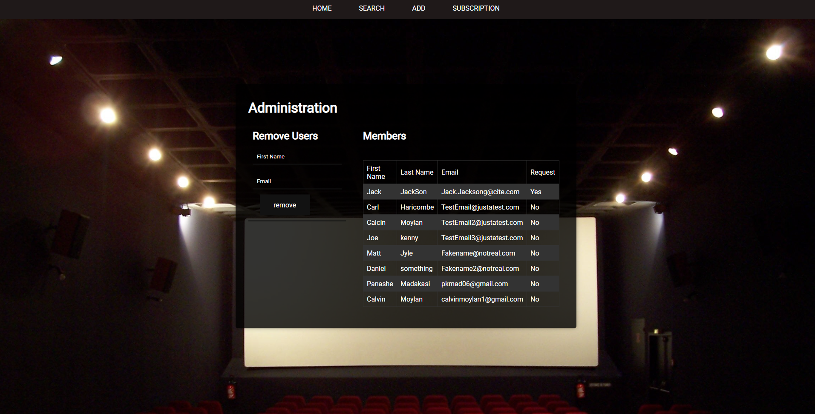

Sign Up Page:  
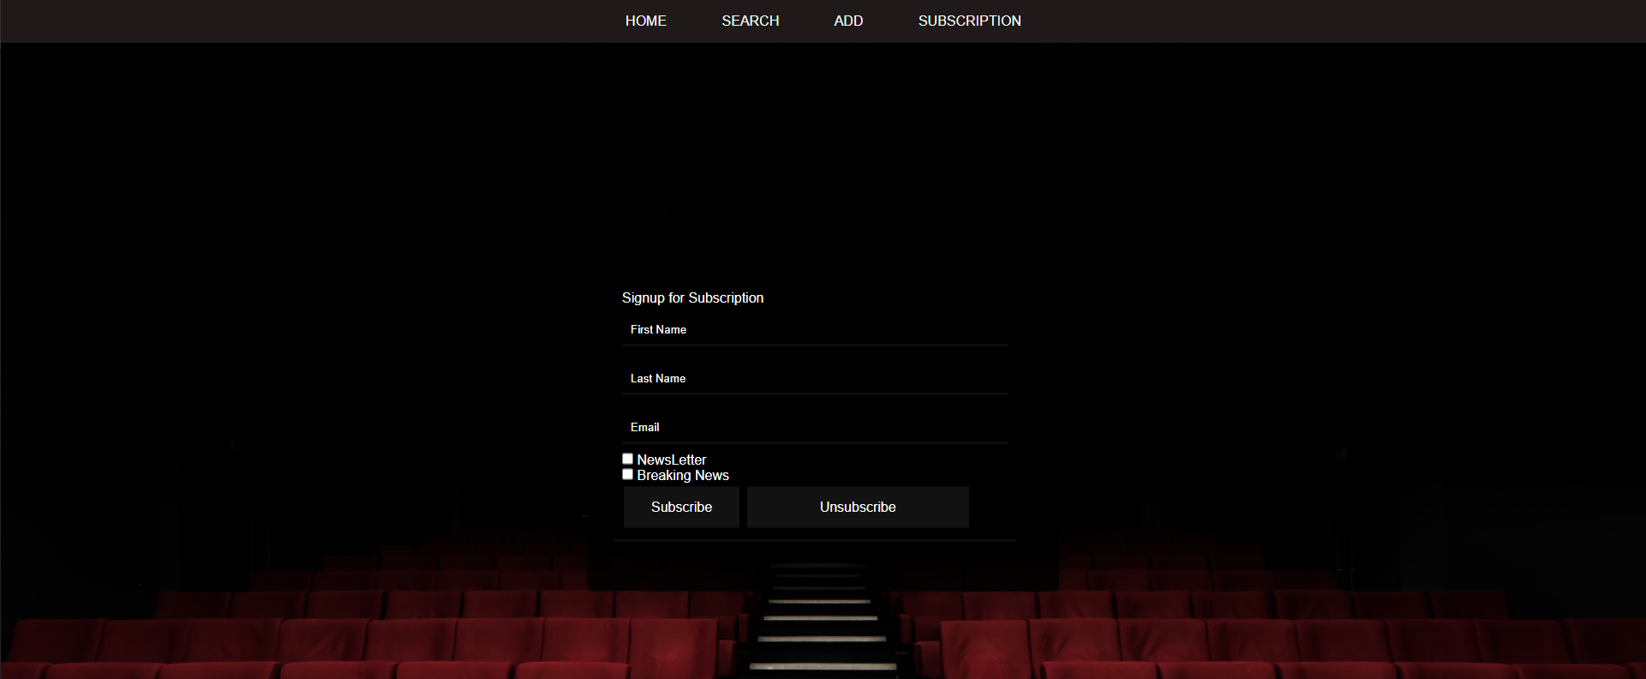

Admin Login page:  
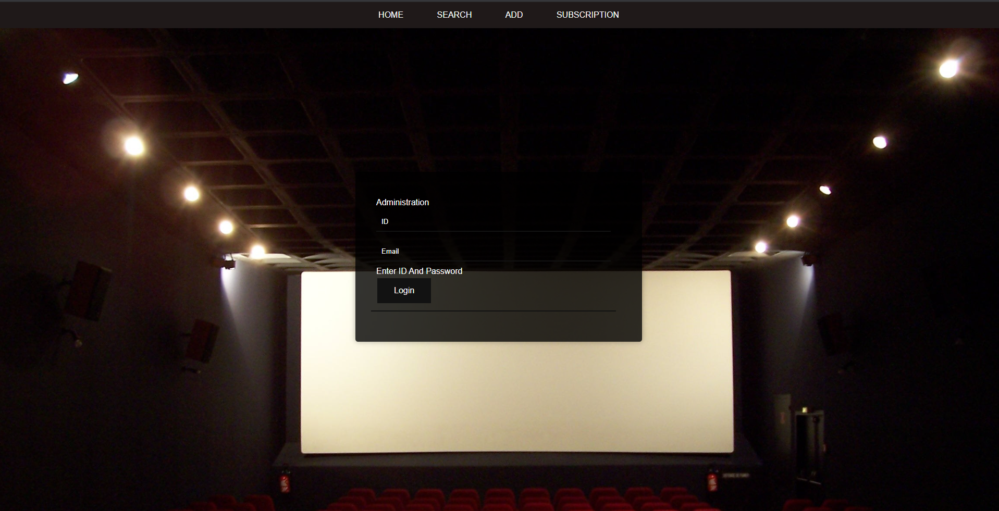

## Defect Tracking

There exists no defect tracking on the current version of the website. This means that we will have no way to see if there are any errors with the website and why it might be erroring. It may be useful to investigate adding some sort of defect tracker in the future.

## Risks

After conducting a review of the final product, I can conclude that the website is not prone to any sort of security risks. This is because all inputs from the user has been sanitised and all sensitive information is stored away from the users behind a database.

## Conclusion

Based on these findings, I can assure the client that the software written by Panashe for sprint two of the Rapid App Development meets all set requirements and it will meet the client’s satisfaction since the website has good performance, has simple and repetitive UI Design, Secure and the Client’s requirements has been met.

# Introduction

Our client Acme Entertainment has requested a User and Admin login and subscribe section to the website which are both linked to a database each, also a section to the site needs to allow an Admin member to remove a User from the site as well as a validation filter set to allow only letters for user login, numbers for admin login and an email type(containing an @ symbol and ending in a .com etc.). A user should be able to unsubscribe and have that request emailed to the admin member

# Scope

## Features (Movie Database website) In Scope

* Ability to allow a user to login
* Ability to allow an admin to login
* Ability to allow an admin member to remove a user and get removal request email from user

## Functional

* Admin login
* User subscribe and unsubscribe
* User removal by the Admin through email
* Admin receives removal request
* Validation filter for email and letters for the name of users and numbers for admin ID

## Non- functional requirements

* The User Database
* Admin Database
* User and login Interface

# Quality Objective

* All features required by client for this sprint is working appropriately
* There is no form of bugs or technical issues

# Roles and Responsibilities

Calvin Moylan(Scrum Master)

* Project management plan (sprint one)
* Master Document Sprint 2 addition
* Source control Snapshot
* Demonstration

Panashe Madakasi

* Coding (Developer)
* Performance Report

Carl Haricombe

* Software Development Testing Plan

# Test Methodology

## RAD (Rapid application Development)

Continuing from the last task given to the team which had to do with creating the website into a multiplatform site that is responsive to different devices. The next task given to the team for the second sprint was a free communications service to people who sign up with their email. A monthly newsletter will be emailed during the last week of each month and a breaking newsflash notification will be sent as they occur. Members will be able to select one or both communications options during the sign-up process. The signup will not require a password but there must be an option to remove their subscription. The removal process should send an email to the administrator requesting the removal of a member’s details from the database. Your team must create a membership page to add new records to a membership database. Design a User Interface for this purpose which will capture the subscriber’s full name and email address. Ensure inputs are fully validated to filter out incorrect or erroneous information.

# Testing strategy

When testing the websites new functions, we will make use a behavioral test when we can test that the changes were done correctly while executing the website. This can also be known as Blackbox testing since it is only focused on front-end testing in the perspective of the end-user and client.

## Quality Assurance

* Quality assurance will up to the Cites management standards evaluation project performance and the hand off complies with customer requirements.

# Testing Environment

|  |  |
| --- | --- |
| **OS** | **Browser** |
| Windows 10 | Chrome |

## Hardware requirements

* Windows 10 (Computer)
* Internet connection
* Peripherals such as a mouse and keyboard
* Monitor

# Test Cases

|  |
| --- |
| Prototype |
| Admin login and Email |
|  |
| User Subscribe |
|  |
| User removal |
|  |
| Validation Filter (User – letters for names) |
|  |
| Validation Filter (Admin – only numbers) |
|  |
| Validation Filter (Email - @ symbol .com etc) |
|  |
| User unsubscribe email |
|  |